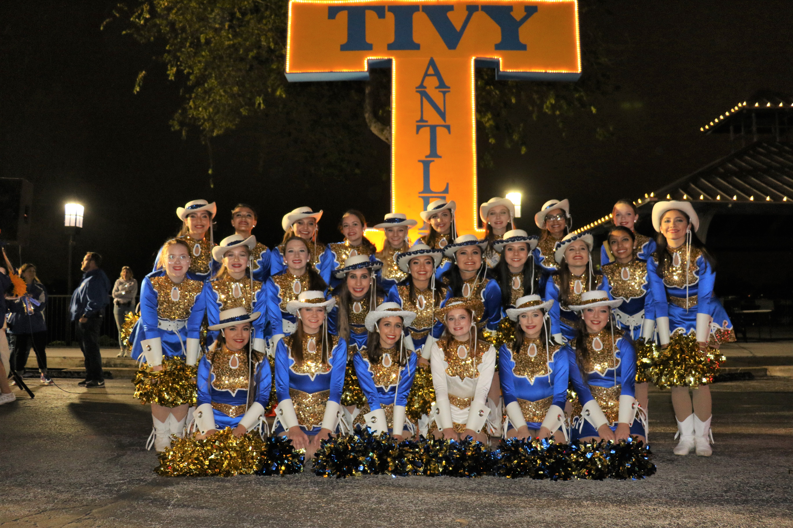

**The purpose of the Tivy Golden Girls and Sapphires organizations are to support KISD athletic teams by:**

* Promoting School Spirit
* Focusing on teamwork
* Inspiring dedication
* Boosting moral

**Participating in a Tivy Dance Team program helps girls on the path toward becoming strong future leaders.**

**These ladies:**

* Develop valuable leadership skills
* Learn to work as a team
* Develop character
* Enhance work ethics
* Learn time management
* Have respect for others
* Develop high self-esteem
* Increase self- confidence
* Develop strong self-discipline
* Develop enhanced concentration and focus

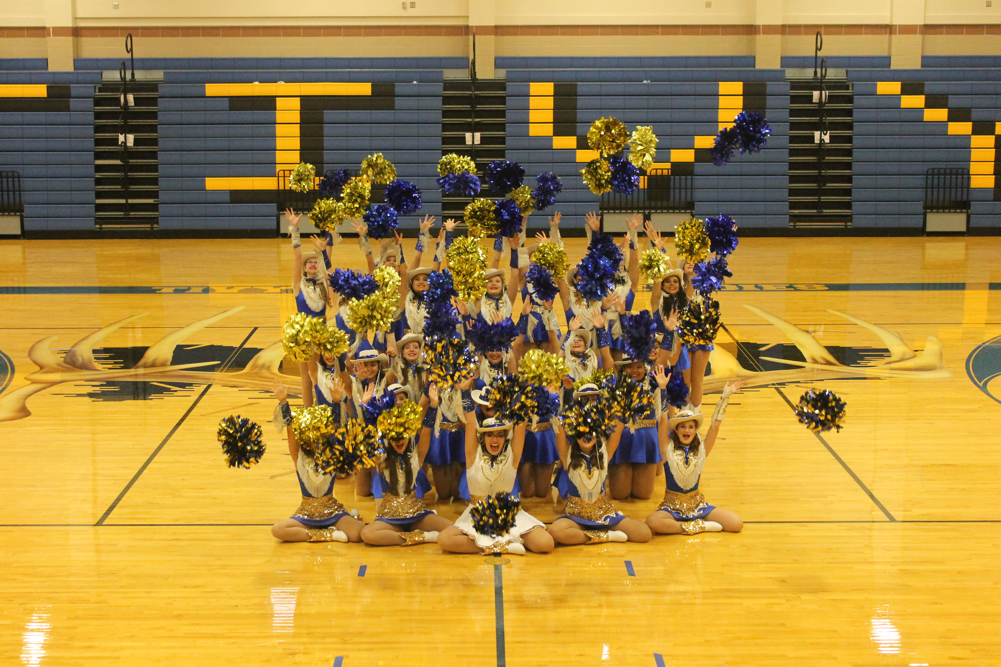

**Family and Friends**

*Bootbacker - $25*

*Name on Golden Girl and Sapphire website

*High Kicking Bootbacker - $50*

All of the benefits of a Bootbacker plus:

*Name in all performance programs

*Super Bootbacker - $100+*

All of the benefits of a High Kicking Bootbacker plus:

* Name on the Golden Girls Spring Show T-Shirt in 2022

**Business and Corporation**

*Standing Ovation Bootbacker - $250+*

All of the benefits of a Super Bootbacker plus:

*Executive Bootbacker - $500+*

All of the benefits of a Standing Ovation Bootbacker plus:

* Two Spring Show T-Shirts for the 2022 Spring Show

*Ambassador Bootbacker - $1000 +*

All of the benefits of an Executive Bootbacker plus:

*Names announced during the Golden Girls half time show.

**Dear Tivy Dance Team Supporters:**

*Between April 20th and the first day of school, the teams will practice for a cumulative of over 100 hours. This fundraiser will not only help us prepare for football season, but will also help us raise funds for winter show, competition season, and our spring show.*

The Tivy Golden Girls are the varsity drill team at Tivy High School. The team not only performs at pep rallies, football games, and competitions but they also put on a wonderfully entertaining winter and spring shows. Our team has distinguished itself in past competitions, receiving many awards including the prestigious Grand Champion Team as well as overall Highest scoring routine in the competition. The Tivy Golden Girls participate in a wide variety of community service projects throughout the year as part of their Golden Girls Commitment.

The Sapphires are the J.V. level dance team in the Golden Girls organization. The Sapphires will perform at all Varsity Football Games, some pep rallies, the Golden Girls’ Winter and Spring Shows, and community events. The Sapphires also participate in a wide variety of community service projects throughout the year as part of their team commitment.

**The Golden Girls and Sapphires**

**appreciate all of your support**

**– past, present,**

**and future!**

**Golden Girls and Sapphires Bootbackers:**

Please check the appropriate box, detach this portion, and return it along with your contribution payable to:

Tivy Golden Girls

**Family/ Friends**

[ ] Bootbacker - $25

[ ] High Kicker Bootbacker - $50

[ ] Super Bootbacker - $100

**Business/ Corporation**

[ ] Standing Ovation Bootbacker -$250

[ ] Executive Bootbacker- $500

*T- Shirt Sizes for spring show Shirts:*

_________________ __________________

[ ] Ambassador Bootbacker - $1,000

Please print your name or company name, as you would like for it to appear on the Website/ T-Shirt

Deadline for name to appear on the Spring Show T-Shirt is Friday, April 22nd.

**Contact Info:**

Name

Phone

Email

Address

**Company Info:** (to be listed on the website)

Company Name

Company Website